Bipeen Sinha
( MCT|AAI|CKA)
AZ-104 Lab

Implement and Manage Azure Managed Disks and Partitioning in a Virtual Machine
Table of Contents
1. Lab Objective 1
2. Lab Scenario 1
3. Description: Azure Managed Disk 1
4. Description: Partition Type 2
5. Lab Create Azure Virtual Machine 2
6. Take Remote (RDP) to Virtual Machine 6
7. Check Available Disk 11
8. Add new Disk to VM 12
9. Configure new Disk in VM 13
10. View the new drive VM 18
11. Learning Objectives 20

Lab Objective
- Create an Azure Virtual Machine
- Understand Azure Managed Disks
- Attach a new data disk to a VM
- Initialize and partition the disk inside Windows
- Format and mount the disk for usage

Lab Scenario
You are working as a Cloud Administrator in an organization migrating workloads to Microsoft Azure.
A newly deployed Virtual Machine requires additional storage for application data. Your task is to:
- Provision a VM
- Add a managed data disk
- Configure the disk inside the OS
- Make it ready for application use
This simulates a real-world enterprise scenario where applications require separate storage volumes for performance and management.

Description: Azure Managed Disk
Azure Managed Disks are storage volumes managed by Azure and used with Virtual Machines.
Key points:
- Azure handles storage accounts automatically
- Provides high availability and durability
- Supports different performance tiers:
  - Standard HDD (cost-effective)
  - Standard SSD
  - Premium SSD (high performance)
In your lab:
You created and attached a Standard HDD (32 GB) disk to the VM.
Think of it like:
“Plugging an external hard drive into a server—but Azure manages the hardware for you.”

Description: Partition Type
When a new disk is added, it must be initialized and partitioned before use.
Common Partition Styles:
- MBR (Master Boot Record)
  - Supports up to 2 TB
  - Older standard
- GPT (GUID Partition Table)
  - Supports large disks (>2 TB)
  - More modern and reliable
In this lab:
- Disk is initialized (default usually GPT in modern systems)
- A Simple Volume is created
- Assigned a drive letter (F:)
Analogy:
Partitioning = Dividing a physical disk into usable sections like rooms in a house.

Lab Create Azure Virtual Machine

- In The Azure Search , Type Virtual Machine and select it

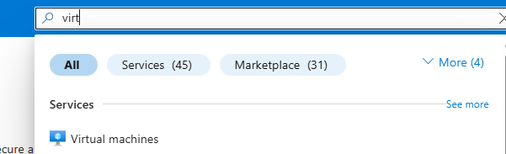

- In Computer Infrastructure Virtual Machine , Select Create Virtual Machine

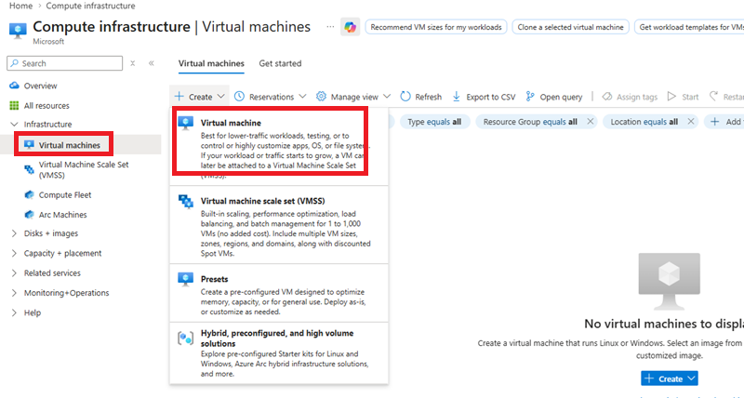

- In The Virtual Machine , Fill the Basic Details and Click Next

Subscription : ODL-AZ-XXXX

VMName : IN-VM-01
Region : WestUS2
Availability Option : No Infrastructure redundancy required
Security type : Standard
Image : Window Server 2019 Datacenter – x64 Gen2
Size : IN-VM-01
Region : Standard_DS1_V2 – 1 CPU , 3.5 GiB Memory
UserName : Vmadmin
Password : Password@123

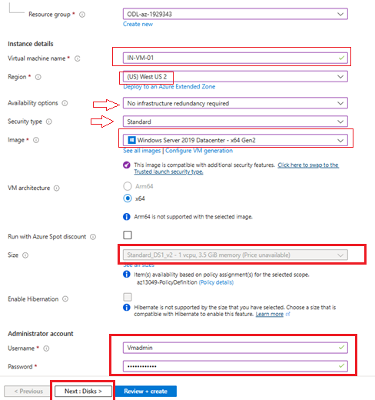

- In The Next Screen ( Disk ) Select Standard HDD and Click Next

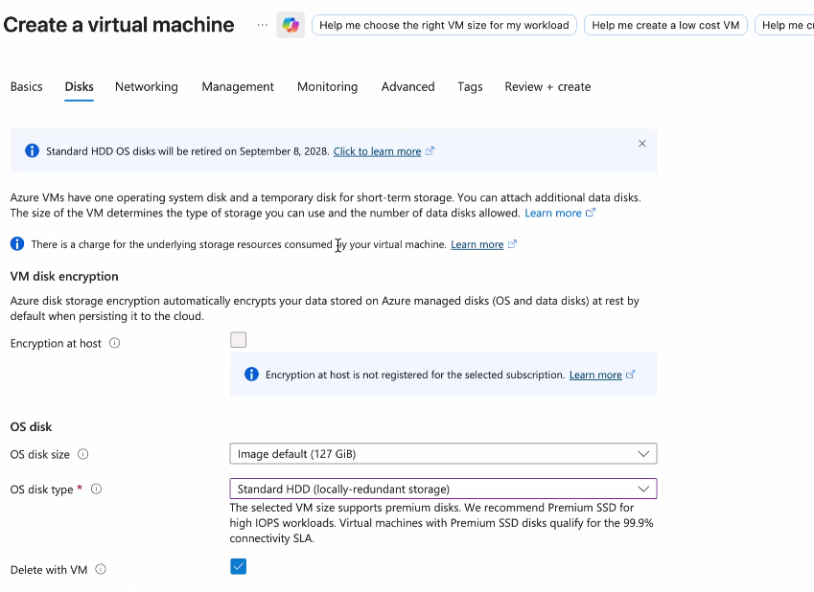

- Click Review + Create Create

- Once Machine Get Created, Click Go To Resource Button and you should be in VM Console

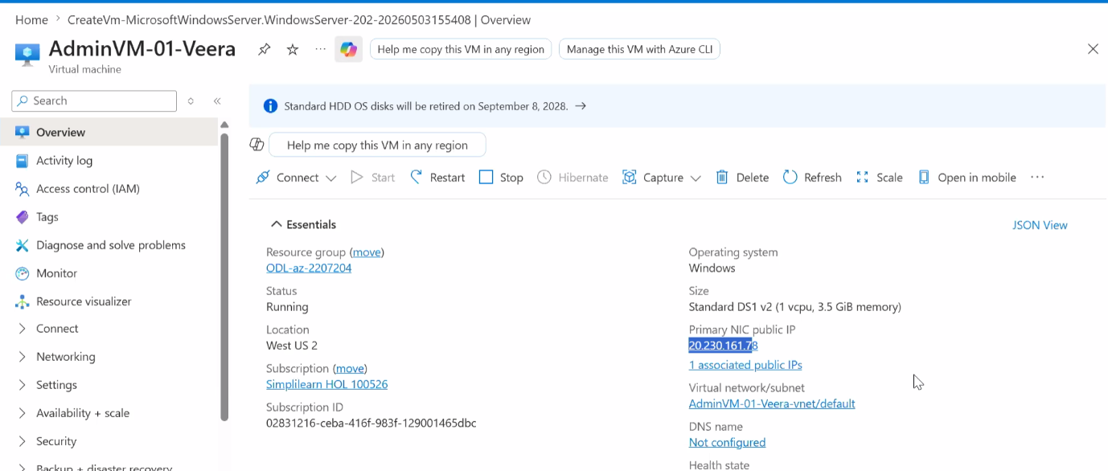

Take Remote (RDP) to Virtual Machine

  - Copy the public IP address from VM Console
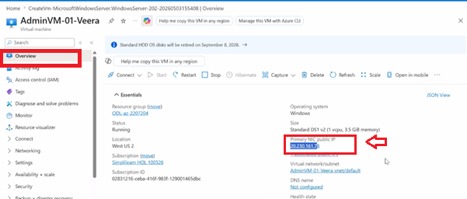

  - From your windows Laptop, Launch Remote desktop
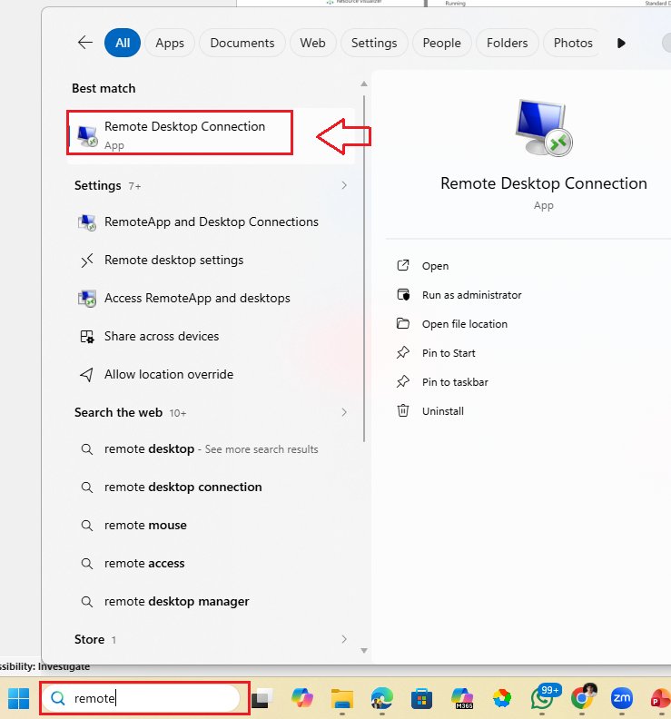

  - Paste the Public IP copied from VM console of Azure and click Connect
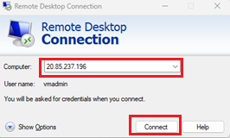

  - Enter following credentials which you enter while creating the VM

User Name : VMAdmin
Password : Password@123

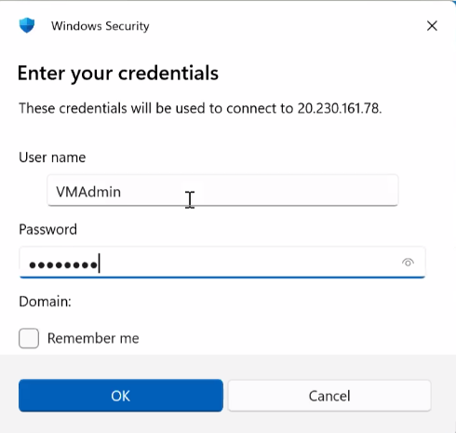
  - Wait for the connection to be established

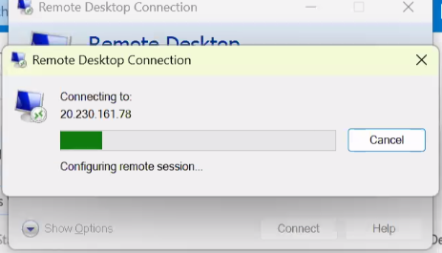

  - Once the connection get established , you may get the Popup , click Yes

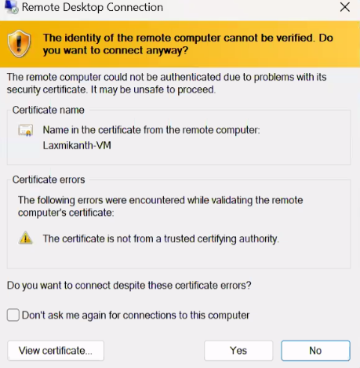

  - Click Accept in send diagnostic data to Microsoft screen

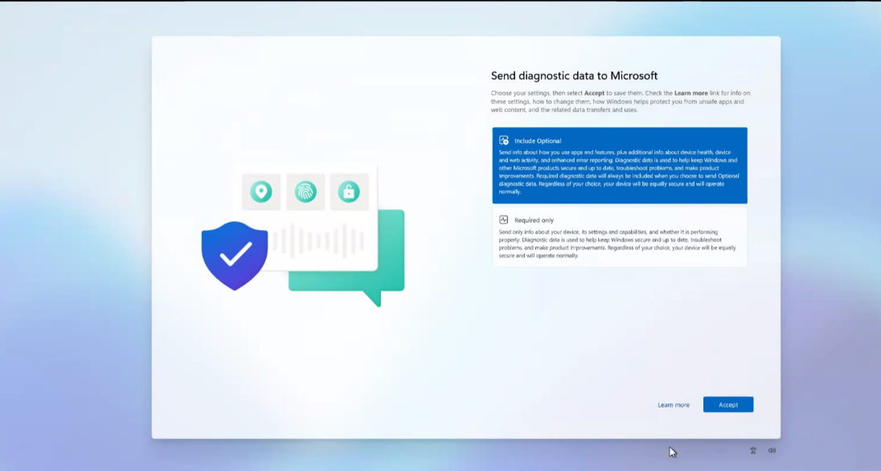

  - You should now see Server Manager

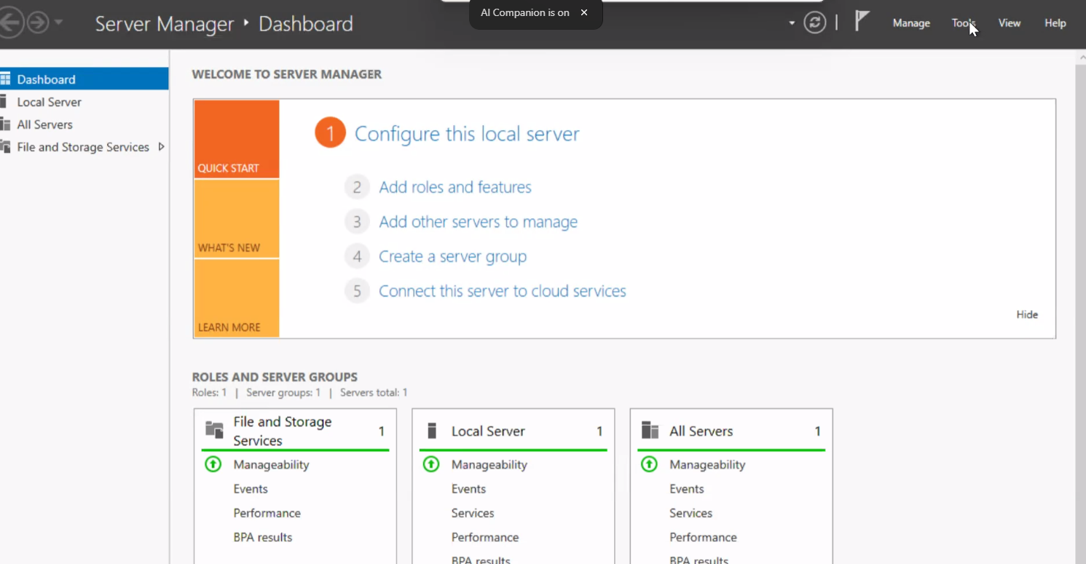

Check Available Disk
  - In the Server Manager Click Tool Menu (Right Side Upper ) and Click Computer Management
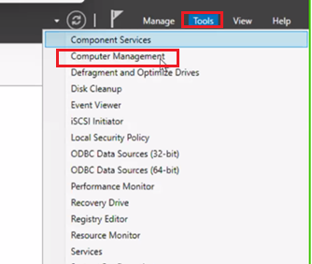

  - In Computer Management click Disk Management (Left Side Tool).
  - In The Disk Management Notice Disk 0 which has OS Partition C:\ Drive and its size approx. 127 GB

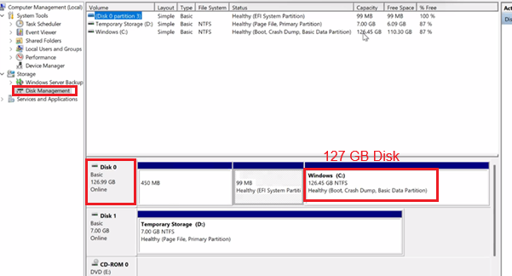

Add new Disk to VM

    - Come back to Azure Portal VM Console
    - From Left Site menu expand Disk Create and attach a new disk
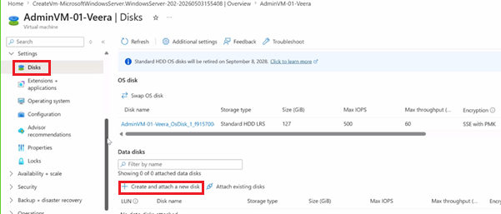

    - Do following setting
Disk Name : DataDisk
Dis Type : Standard HDD
Size (GB) : 32 GB
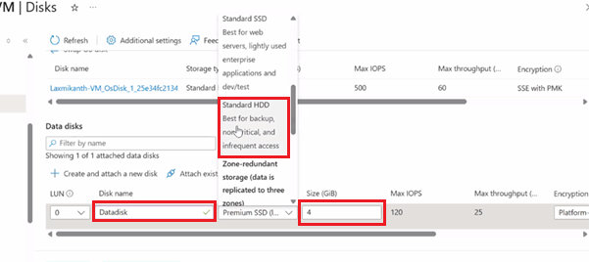

    - Click Apply to add the Disk

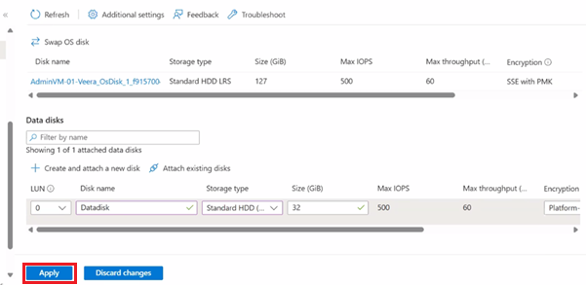
    - Wait for the message “Updated virtual machine”

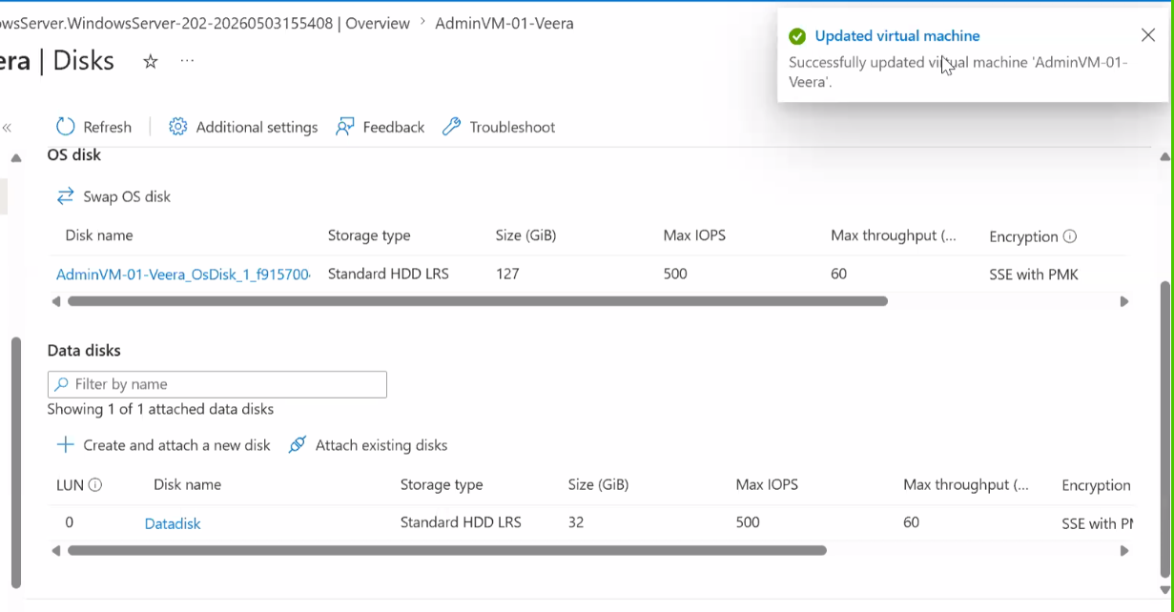

Configure new Disk in VM

    - Come back to VM (Remote) Computer Management Disk Management
    - You should notice Disk 2 has been added. Right now Disk 2 is unknown
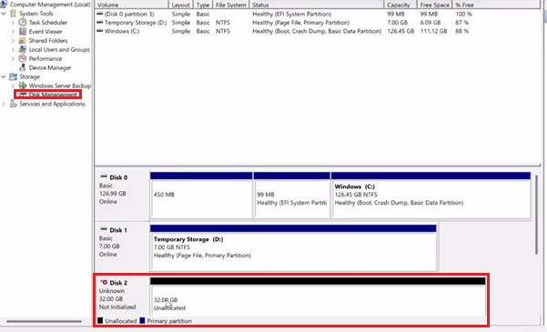

    - Right click the unknow ( Disk 2) and click Initialize Disk from menu

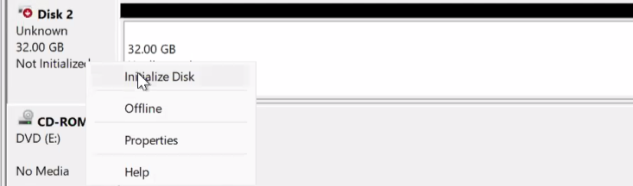
    - Click OK to initiate the initialization of disk

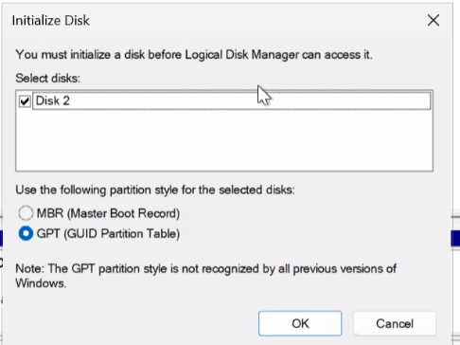
    - Disk 2 now should show online
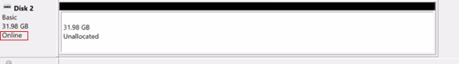

    - Right click the Unallocated space and click New Simple Volume
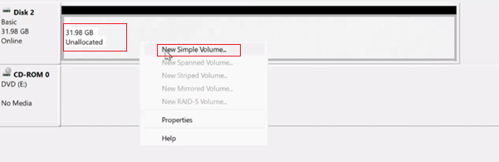

    - Click Next to New Simple Volume Wizard

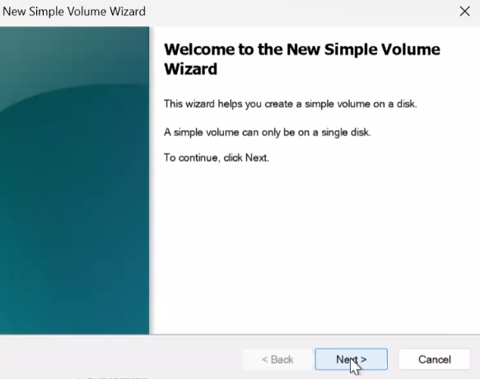
    - Click Next to size

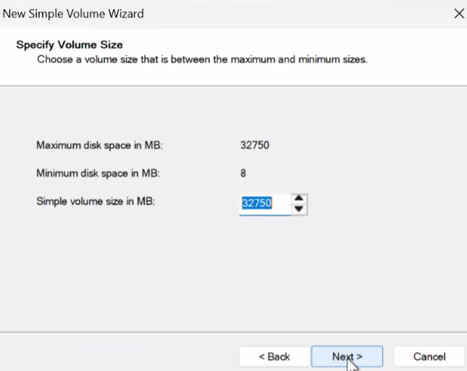
    - Click Next to Assign drive letter

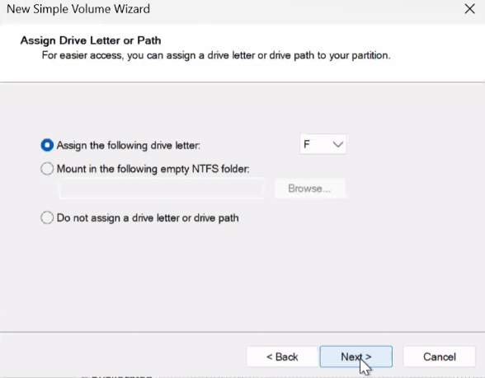
    - Click Next to Format Partition
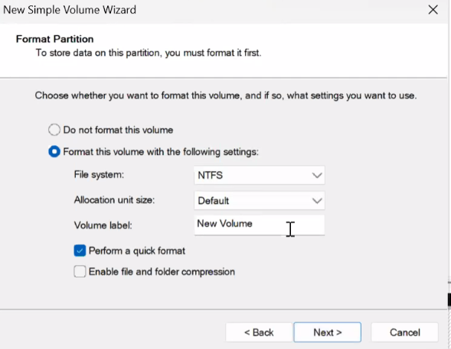

    - Click Finish to complete the drive creation

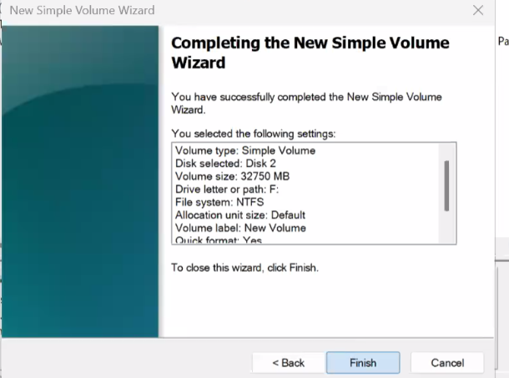

View the new drive VM

    - You should see new partition get created

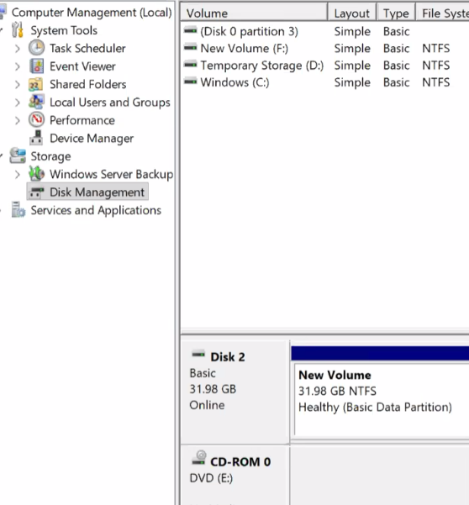
    - Now open File Explorer in VM ( Click Start button and click File Explorer )

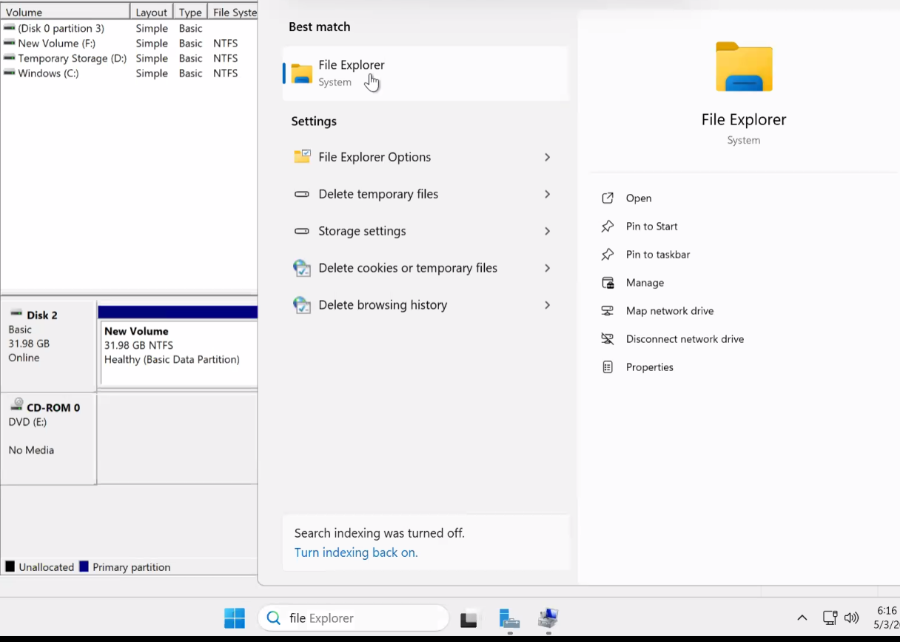
    - You should notice new drive F:\ appear in This PC

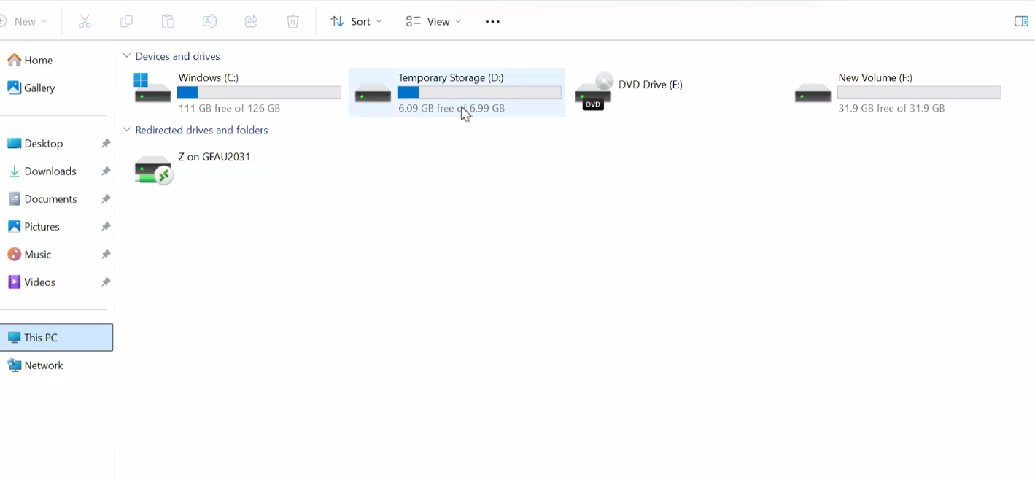

Learning Objectives
By the end of this lab, learners will be able to:
- Understand Azure Virtual Machine storage architecture
- Explain what Azure Managed Disks are
- Differentiate between disk types (HDD, SSD, Premium)
- Attach a managed disk to an Azure VM
- Initialize a disk using Disk Management
- Create and format a partition
- Assign drive letters and verify disk availability
- Connect to VM using RDP and perform storage operations

